Sprint 2 - Accuracy Design Document

November 18, 2021

**Table of Contents**

**1.** **EXECUTIVE SUMMARY 3**

1.1 Project Overview 3

1.2 Purpose and Scope of this Specification 3

**2.** **PRODUCT/SERVICE DESCRIPTION 3**

2.1 Product Context 3

2.2 User Characteristics 3

2.3 Assumptions 3

2.4 Constraints 3

2.5 Dependencies 4

**3.** **REQUIREMENTS 4**

3.1 Functional Requirements 5

3.2 Security 5

*3.2.1* *Protection 5*

*3.2.2* *Authorization and Authentication 6*

3.3 Portability 6

**4.** **REQUIREMENTS CONFIRMATION/STAKEHOLDER SIGN-OFF 6**

**5.** **SYSTEM DESIGN 6**

5.1 Algorithm 6

5.2 System Flow 6

5.3 Software 6

5.4 Hardware 6

5.5 Test Plan 7

5.6 Task List/Gantt Chart 7

5.7 Staffing Plan 7

# Executive Summary

## Project Overview

* The goal of this project is to construct a plan that will allow our Sphero robot to complete the accuracy course in HH208.

## Purpose and Scope of this Specification

**In scope**

* Completing the requirements of the Sprint-2 accuracy course.

**Out of Scope**

* Completing the requirements of the Sprint 1-Endurance course.
* Completing the requirements of the Sprint 3-Agility course.

# Product/Service Description

## Product Context

* This project is not related to the other Sprint project
* Each of the Sprint projects are self-contained.

## User Characteristics

* Student/Teacher
* Programmer

## Assumptions

* Sphero Edu will be used for designing the code
* HH208 will be available to test our code
* The sphero robot will be used for this project

## Constraints

* Must use Sphero block code
* Must use the accuracy course in HH208

## Dependencies

* HH208 will need to be available to test the robot on the accuracy course
* The Sphero robot will need to be available to test our block code

# Requirements

## Functional Requirements

|  |  |  |  |  |  |
| --- | --- | --- | --- | --- | --- |
| **Req#** | **Requirement** | **Comments** | **Priority** | **Date Rvwd** | **SME Reviewed / Approved** |
| ENDUR_01 | Sphero robot must run the figure eight course 5 times. |  | 1 | 11/17 |  |
| ENDUR_02 | Sphero robot must follow the course outline |  | 1 | 11/17 |  |
| ENDUR_03 | Once the path is complete the robot must flash multicolored for 5 seconds and say “I’m the winner.” |  | 1 | 11/17 |  |
| ENDUR_04 | The robot must finish in the same place that it started. |  | 1 | 11/17 |  |
|  |  |  |  |  |  |
|  |  |  |  |  |  |
|  |  |  |  |  |  |
|  |  |  |  |  |  |
| ENDUR_XX |  |  |  |  |  |

## Security

### Protection

* A password to the Sphero Edu account is required to access the block code.
* The SDD and Gantt Chart can not be accessed without the host’s permission.

### Authorization and Authentication

* You must enter the correct email and password to be authorized to access the block code
* The document creator must authorize access to the SDD and the Gantt Chart

## Portability

* The computer where the block code is located is portable.
* The Sphero robot is portable
* The HH208 accuracy course is not portable

# Requirements Confirmation/Stakeholder sign-off

Include documentation of the approval or confirmation of the requirements here. For example:

|  |  |  |
| --- | --- | --- |
| **Meeting Date** | **Attendees (name and role)** | **Comments** |
| 11/17/21 | Patrick Frohn | Confirmed all |
| 11/17/21 | Madison Kapuscinski | Confirmed all |

# System Design

## Algorithm

* Start
* Heading 0 degrees
* Main LED Blue
* Count = 0
* Spin 365 degrees
* Spin - 365 degrees
* If Count = <5; repeat steps 5-6
* Fade from blue to red
* Speak ‘I am the winner!’ and wait
* Stop

## System Flow

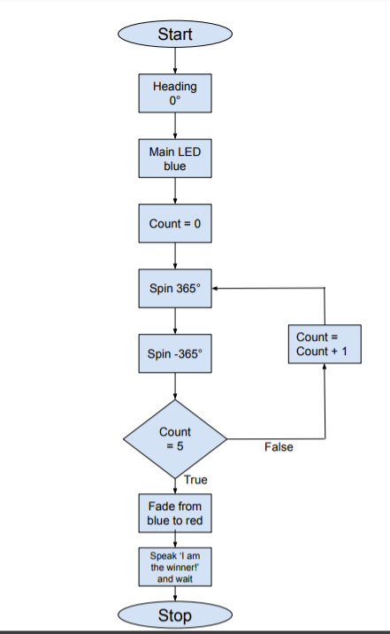

## Software

Describe software languages/platforms/api’s used to develop and deploy this application

* Sphero Edu block code

## Hardware

Describe hardware platforms that were used to develop, test and demonstrate this application

* Sphero mini robot

## Test Plan

Include a test plan showing all unit tests performed for this application, Include test rational, test date, staff member, pass/fail status

|  |  |  |  |  |  |
| --- | --- | --- | --- | --- | --- |
| **Reason for Test Case** | **Test Date** | **Expected Output** | **Observed Output** | **Staff Name** | **Pass/Fail** |
| Test the spin in the code for circle 1. | 11/17 | Robot would stay on track and complete the circle. | The robot stayed on track and completed circle 1. |  | Pass |
| Test the spin in the code for circle 2. | 11/17 | The robot would stay on track and complete the circle. | The robot went outside of the circle and did not stay on the path. |  | Fail |
| Adjust the speed of the robot for circle 2 | 11/17 | The robot will stay stay on the path and complete the circle | The robot stayed on the path of circle 2 . |  | pass |
| Testing the code on the whole | 11/17 | The robot will stay on the path for the figure eight | The robot did not stay on the path at all. |  | Fail |
| Testing the code for speaking and color change | 11/17 | The robot will flash multi-colored for 5 seconds and then say “I’m the Winner” | The robot flashed multi colored for 5 seconds and said I’m the winner |  | Pass |
| Testing code for the whole course | 11/17 | The robot will complete the course with minimal time off of the track | The robot completed the course with minimal time off of the track |  | Pass |
|  |  |  |  |  |  |
|  |  |  |  |  |  |
|  |  |  |  |  |  |
|  |  |  |  |  |  |
|  |  |  |  |  |  |

## Task List/Gantt Chart

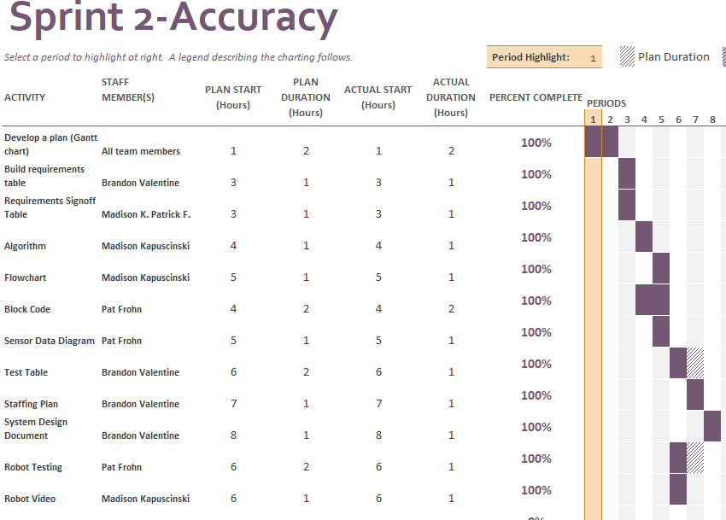

## Staffing Plan

Insert a chart/table that depicts the roles and responsibilities of each team member that worked on this project

|  |  |  |  |
| --- | --- | --- | --- |
| Name | Role | Responsibility | Reports To |
| Patrick Frohn | Programmer | * Block Code * Sensor Data Diagram * Gantt Chart * Robot Testing * Requirements Sign Off Table | Madison K.  Brandon V. |
| Madison Kapuscinski | Plan Designer | * Algorithm * Flowchart * Gantt Chart * Robot Video * Requirements Sign off table | Patrick F.  Brandon V |
| Brandon Valentine | Information Recorder | * System Design Document * Test Table * Staffing Plan * Gantt Chart * Requirements Table | Madison K.  Patrick F. |